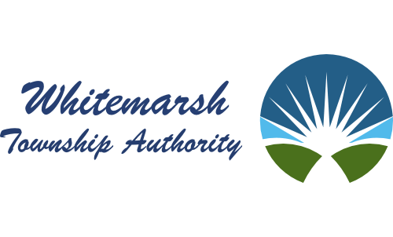

2015 Joshua Road
Front Building
P.O. Box 447
Lafayette Hill, PA 19444
484-344-5230
484-368-3927 (Fax)
www.whitemarshauthority.org

Dear Residents of Harts Lane,
In mid-2020, Pennsylvania Department of Environmental Protection Representatives identified a section of Harts Lane from its intersection with Paddock Lane extending south approximately 1,700 linear feet as a “Sewage Facilities Needs Area,” and directed Whitemarsh Township to perform sewage planning as part of a proposed amendment to the Township’s Official Sewage Facilities Plan. As a result, the Whitemarsh Township Authority, on behalf of Whitemarsh Township, is preparing an update to the Township’s Official Sewage Facilities Plan for this area of the Township. A sketch of the study area is attached.
Of the alternatives studied, the construction of a low-pressure sewer sanitary sewer extension to the Authority’s existing sewer main on Harts Ridge Road appears to be the most feasible option from both an economic and constructability perspective. Piping for a small diameter sanitary force main would be installed along Harts Lane from the entrance to the Miquon School to the intersection of Paddock Lane and Harts Lane. A pump station would be installed near the intersection, that would pump the sewage up to an existing sewer main on Harts Ridge Road. The estimated costs of the proposed public improvements are on the order of $790,000 which would equate to approximately $36,000 per household.
You are invited to meeting with Authority Representatives and the other property owners within the study area to be held at 12:00 p.m. on Wednesday, March 22, 2023, and at 6:00 p.m. on Thursday, March 23, 2023, at the Township Building (616 Germantown Pike, Lafayette Hill, PA 19444) to review the elements of the draft plan and the potential project timeline. Please note that this proposed meeting is being held for informational purposes only. The plan is still in draft form, and, cannot be approved prior it’s completion and subsequent review by the Township Planning Commission, Montgomery County Planning Commission and the Montgomery County Health Department. Lastly, everyone should recognize that even if the project moves forward, even an optimistic schedule would not foresee construction until sometime in 2024 or 2025 given the need for certain regulatory approvals as well as the Authority’s desire to seek grant money to help defray the anticipated costs of the proposed sewer construction.
Should you have any questions, please contact our office.
Warmest Regards,
Whitemarsh Township Authority

